HL History Year 1 Summer Work
Directions: Please watch some historical films and documentaries to brainstorm topics for your Internal Assessment (IA). You will then rank the topics in the order of your interest and develop a working research question using the template below.
With your parent’s approval you can opt watch some of the following movies and/or documentaries to brainstorm topic ideas. Many of these titles are available at the local library. You are not required to watch these but if you do, first read about the movie, review the ratings and parent guide. Please talk with your parent(s) first to make sure they approve of you watching a movie/documentary on the list below.
- Mandela: Long Walk (Paper 1: Rights & Protest – Apartheid in South Africa)
- Invictus (Paper 1: Rights & Protest – Apartheid in South Africa)
- Motorcycle Diaries (Paper 2: Authoritarian States – ‘Che Guevara’; Paper 3: Political Developments in Latin America)
- Book Thief (Paper 2: Authoritarian States – Germany)
- Schindler’s List (Paper 2: Authoritarian States – Germany)
- The Rise of Evil (Paper 2: Authoritarian States – Germany)
- The Lost City (2005) (Paper 2: Authoritarian States – Cuba; Paper 3: Populist Leaders)
- How to Become a Tyrant (Netflix) (Paper 2: Authoritarian States – Various Leaders)
- Selma (Paper 1: Rights & Protest; Paper 3: Civil Rights in the Americas)
- Genius: MLK/X (Disney+) (Paper 1: Civil Rights & Paper 3: Civil Rights and Social Movements in the Americas)
- Te Ata (Netflix) (Paper 3: Civil Rights in the Americas)
- Killers of the Flower Moon (Amazon Prime) (Paper 3: Civil Rights and Social Movements in the Americas)
- Montford: The Chickasaw Rancher (Netflix) (Paper 3: Civil Rights and Social Movements in the Americas)
- Viceroy’s House (Paper 2: Independence Movements – India)
- Gandhi (Paper 2: Independence Movements – India)
- Cuba Libre (Netflix) (Paper 2: Independence Movements – Cuba; Paper 3: Populist Leaders)
- Machuca (Paper 3: Political Developments in Latin America)
- The Pinochet Case (Amazon Prime) (Paper 3: Political Developments in Latin America)
- Salvador Allende (Amazon Prime) (Paper 3: Political Developments in Latin America)
- The Official Story (Amazon Prime) (Paper 3: Political Developments in Latin America)
- Romero (Amazon Prime) (Paper 3: Political Developments in Latin America)
- Under Fire (Amazon Prime) (Paper 3: Political Developments in Latin America)
- Evita (Amazon Prime) (Paper 3: Political Developments in Latin America)
- Thirteen Days (Amazon Prime) (Paper 3: Political Developments in Latin America & Cold War in the Americas)
- The Vietnam War (PBS series) (Paper 3: Cold War in the Americas)
- The Front Line (Paper 3: Cold War in the Americas – Korean War)
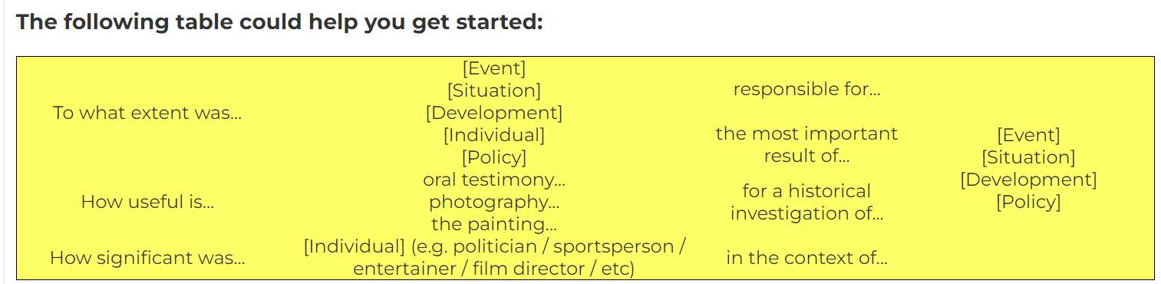

Last Name:
First Name:
Block:

Research Topic | Research Question
1.

2.

3.

4.

5.

IB History HL Summer Assignments (Juniors to Seniors)
Mrs. Heidi Dindial-Thompson
DindialThompsonH@pcsb.org

Assignment #1 – Internal Assessment
We’ve done the bulk of the work over the school year. Now, focus on proofing, re-reading, and revising your History IA.

Assignment #2 – Review Quizlets
Review Topic 8: Independence Movements 1800-2000
- Paper: 2 Independence Movements (1800-2000), Gandhi and India, Jinnah and Pakistan
- Origins and rise of independence movements in Cuba questions
Review Paper 3 Section 14: Political Developments in Latin America
- Guerilla War in El Salvador
- Castro & Cuba; Castro’s Rise to Power
- Military Dictatorship Fulgencio Batista
- Populist Leaders – Juan Peron
Preview Topic 10: Authoritarian States
- Nazi Germany & Hitler
- Hitler Historiography & Perspectives

Assignment #3 – Short Review Videos
Review Topic 8: Independence Movements 1800-2000
- The Cuban Revolution Explained: World History Review
- India Pakistan Partition Documentary BBC
Preview Topic 10: Authoritarian States
- Authoritarian Techniques in Nazi Germany
- Cuban Revolution & Fidel Castro

Assignment #4 – Review Class Notes & Handouts
Take time to study your notes from class. Feel free to create index cards, annotate, highlight, and etc. to review the content.

Assignment #5 – Review Practice Paper 1: Case Study Apartheid in South Africa
- P1 Practice Why was Apartheid Introduced
- P1 Practice How important was the role of women in the anti-apartheid struggle
- P1 Practice Mandela Move to Violence

Assignment #6 – Civil Rights
- Explore and read about Civil Rights in InThinking.

